OOPs LAB
Spring Semester 2026
Assignment 8
Name – Soham Chakraborty
Roll No – 22CS02002

Section 1 –
Q1) UML Diagram
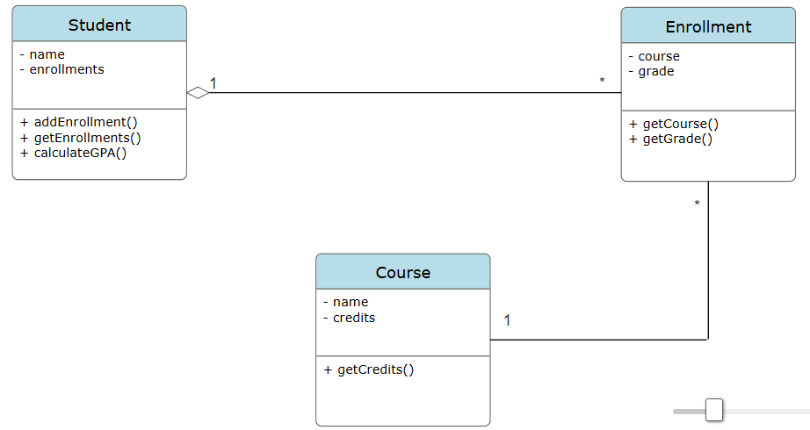

Here we are using the concept of Expert Pattern Student is the expert Class here and hence, GPAUtil is removed (entirely) and instead computeGPA is put into Student since it has all the information to compute the GPA i.e. all Courses grade and credits. This reduces coupling between Student and GPAUtil.

Q2) UML Diagram
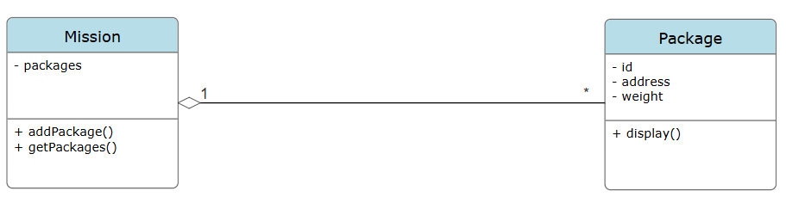

Creator Pattern is used here. Putting addPackage() inside Mission reduces coupling between Main and Package. Since, Main no longer directly calls to Package also Mission and Package were already previously coupled, so it doesn’t affect coupling between them.

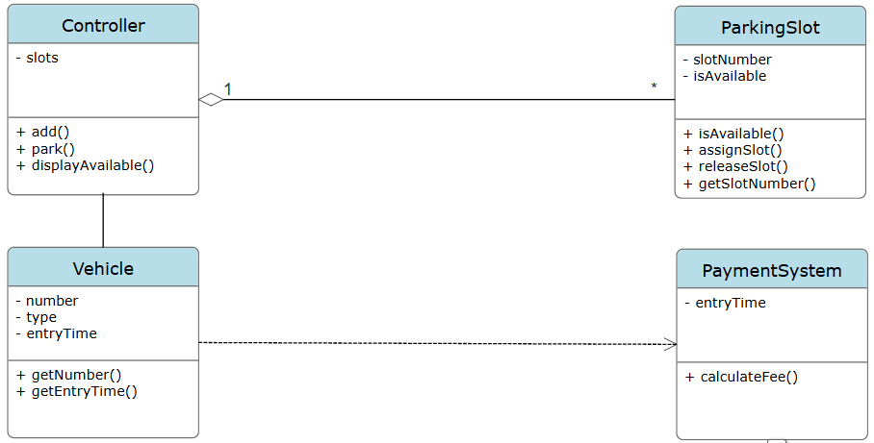
Q3) UML Diagram

Class Controller uses Controller Pattern and handles all the UI operations such as display and distribution tasks upon vehicle parking. Reduces coupling since now Main now longer needs to use ParkingSlot which is handled inside Controller. Also since PaymentSystem is the Expert class it handles the calculateFee() without interference from Main.
Section 2 –
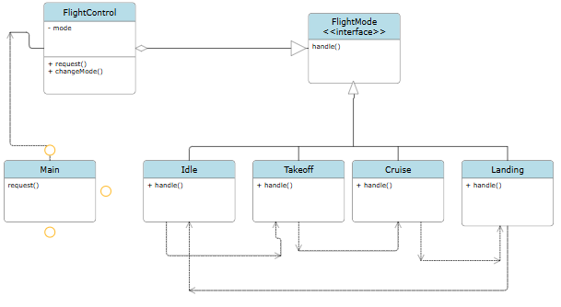
UML Diagram:

The given FlightControl mechanism is using State Design Pattern. FlightMode can be in 4 different states – Idle, Takeoff, Cruise and Landing. Each of these classes use the same Interface FlightMode which implements function handle() and then shifts the state (FlightMode) to the next state as shown in the UML diagram.

